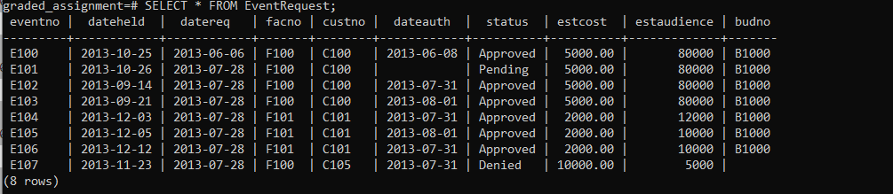

CREATE TABLE eventrequest(

eventno VARCHAR(8) NOT NULL,

dateheld DATE NOT NULL,

datereq DATE NOT NULL,

facno VARCHAR(8) NOT NULL,

custno VARCHAR(8) NOT NULL,

dateauth DATE,

status VARCHAR(8) NOT NULL CHECK (status IN ('Pending', 'Denied', 'Approved')),

estcost DECIMAL(10, 2) NOT NULL,

estaudience INT NOT NULL CHECK (estaudience > 0),

budno VARCHAR(8),

CONSTRAINT pkEventNo PRIMARY KEY (eventno),

CONSTRAINT fkFacNoEventReq FOREIGN KEY (facno) REFERENCES facility (facno),

CONSTRAINT fkCustNo FOREIGN KEY (custno) REFERENCES customer (custno)

);